Practical 5: Analysing Data using Table Calculations in Tableau
a) Apply quick table calculations (running total, percent of total)
b) Create moving averages and cumulative metrics
c) Perform year-over-year growth analysis
d) Use ranking functions (Top N, Bottom N)
e) Implement window functions (WINDOW_SUM, WINDOW_AVG)
f) Customize addressing and partitioning
g) Create dynamic titles and labels using table calculations

A: Apply quick table calculations (running total, percent of total)
Quick Table Calculations allow you to apply complex computation logic (like cumulative sums or proportions) to your visualizations instantly without manually writing code.
Task 1: Create a Running Total of Votes by City
A Running Total calculates a cumulative sum across a dimension (e.g., adding each city’s votes to the running sum of all previous cities).
1. Open a new worksheet and rename it: Running Total - Votes.
2. From the Data Pane, drag listed_in(city) to the Rows shelf. 3. Drag votes to the Columns shelf. (Tableau will automatically aggregate it as SUM (votes)).
4. Convert to Quick Table Calculation:
o Right-click the SUM (votes) pill on the Columns shelf.
o Hover over Quick Table Calculation and select Running Total.
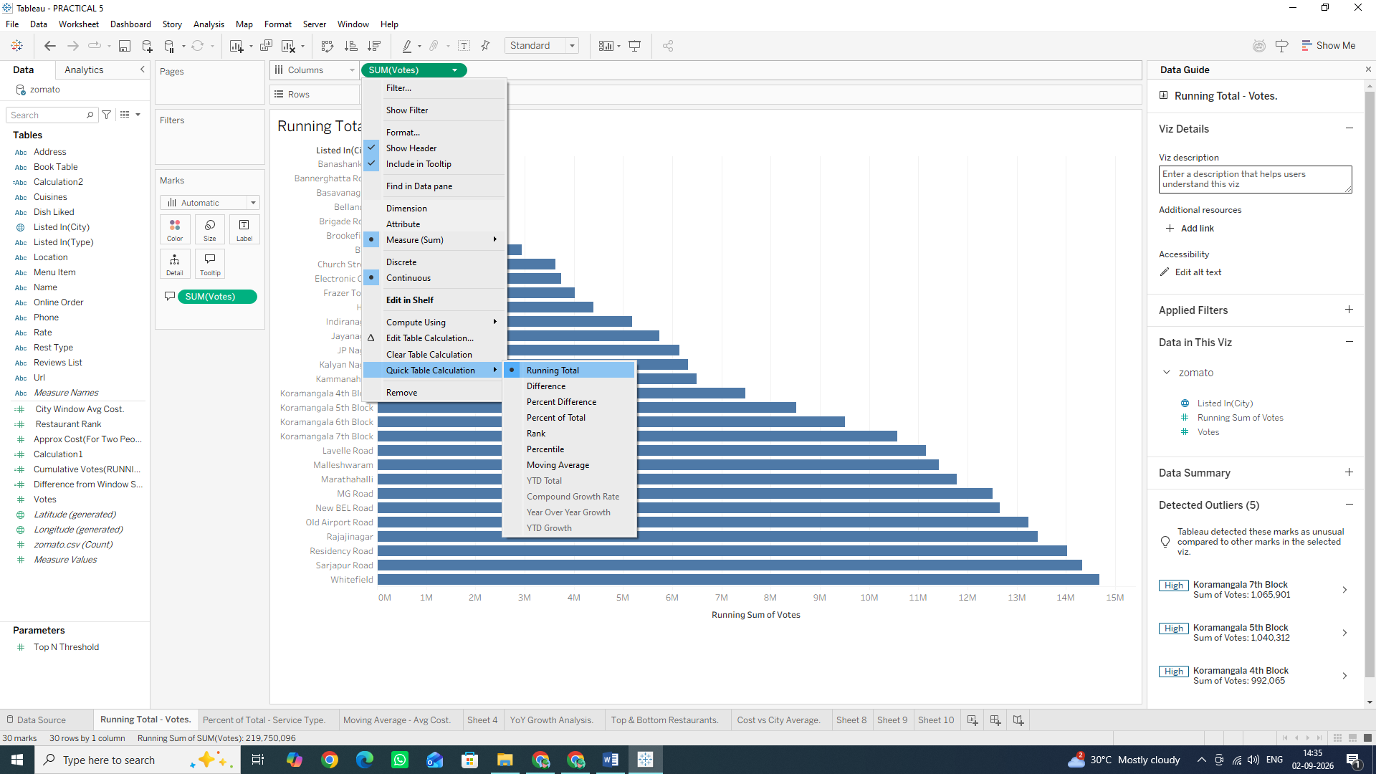
5. Add Visual Context (Secondary Measure):
o Drag votes from the Data Pane again and drop it directly onto the Tooltip mark in the Marks Card.
o Result: Now when you hover over a bar, you will see both the individual city's vote count and the cumulative total up to that city.
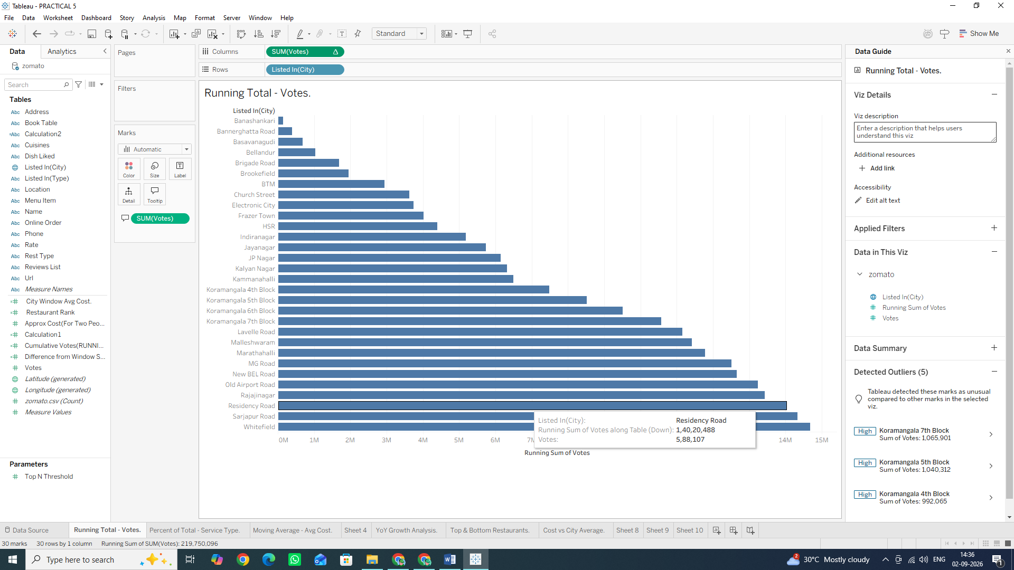

Task 2: Create a Percent of Total across Categories
A Percent of Total transforms raw numbers into relative percentages of the entire view (summing to 100%).
1. Open a new worksheet and rename it: Percent of Total - Service Type.
2. Drag listed_in(type) (e.g., Buffet, Cafes, Delivery, Dining) to the Rows shelf.
3. Drag votes to the Columns shelf.
4. Right-click the SUM (votes) pill on the Columns shelf.
5. Hover over Quick Table Calculation and select Percent of Total.
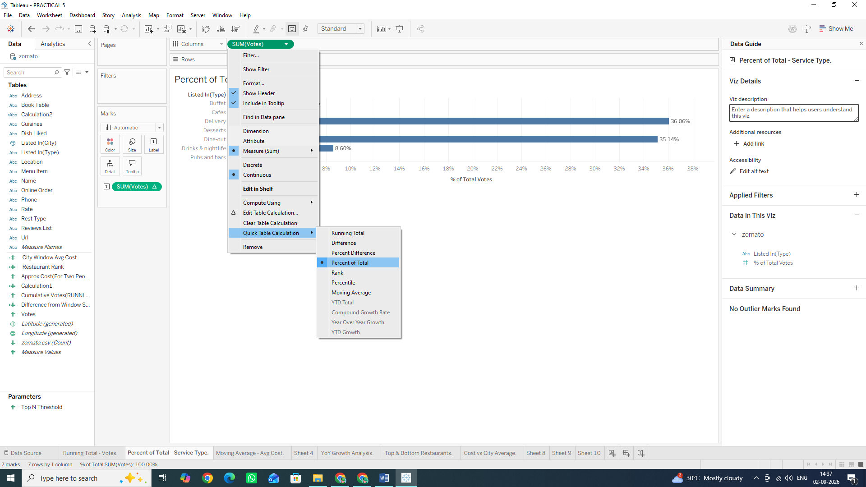
6. Format as Percentage: o Right-click the SUM (votes) pill again and select Format...
o Under the Pane tab on the left formatting panel, click Numbers $\rightarrow$ Percentage (set to 1 or 2 decimal places).
7. Drag SUM (votes) (with the table calculation icon Δ) onto the Label mark so the exact percentages display on top of each bar. (NOTE: IF YOU WANT TO SEE THE BAR GRAPH TOO, YOU CAN DRAG SUM (votes) TO LABEL ICON BY HOLDING CTRL KEY)

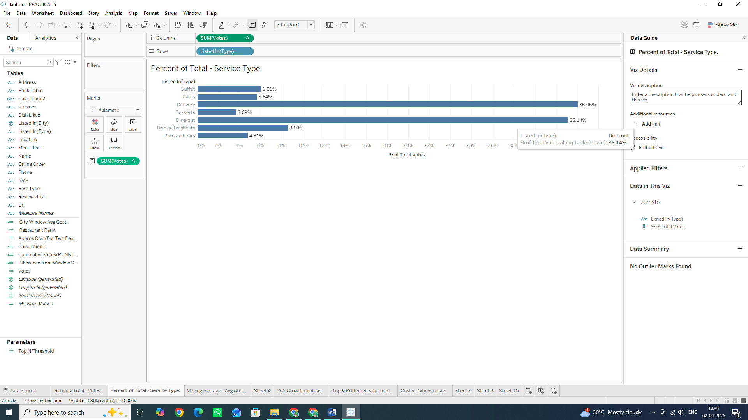
Why We Are Doing It
• Running Total: Crucial for tracking cumulative growth, target attainment over time, or Pareto analysis (80/20 rule).
• Percent of Total: Essential for understanding market share or contribution breakdown across business segments.
B: Create moving averages and cumulative metrics
Moving averages are used to smooth out short-term fluctuations and highlight longer-term trends or cycles in data.
Task 1: Create a Moving Average Calculation
We will create a moving average to smooth out variations in pricing across restaurants based on vote counts or listing order.
1. Open a new worksheet and rename it: Moving Average - Avg Cost.
2. Drag listed_in(city) to the Rows shelf.
3. Drag approx_cost (for two people) to the Columns shelf. (Note: If Tableau imports this field as a String/Dimension due to commas, right-click the field in the Data Pane, select Change Data Type ◊ Number (whole), then drag it as AVG or after placing it on column it doesn’t shows AVG right click on it Hover at Measure and click Average).
4. Convert to a Moving Average Quick Table Calculation:
o Right-click the AVG (approx_cost...) pill on the Columns shelf.
o Hover over Quick Table Calculation and select Moving Average
5. Customize the Moving Window:
o Right-click the modified AVG(approx_cost...) pill again (it now has a Δ symbol).
o Select Edit Table Calculation...
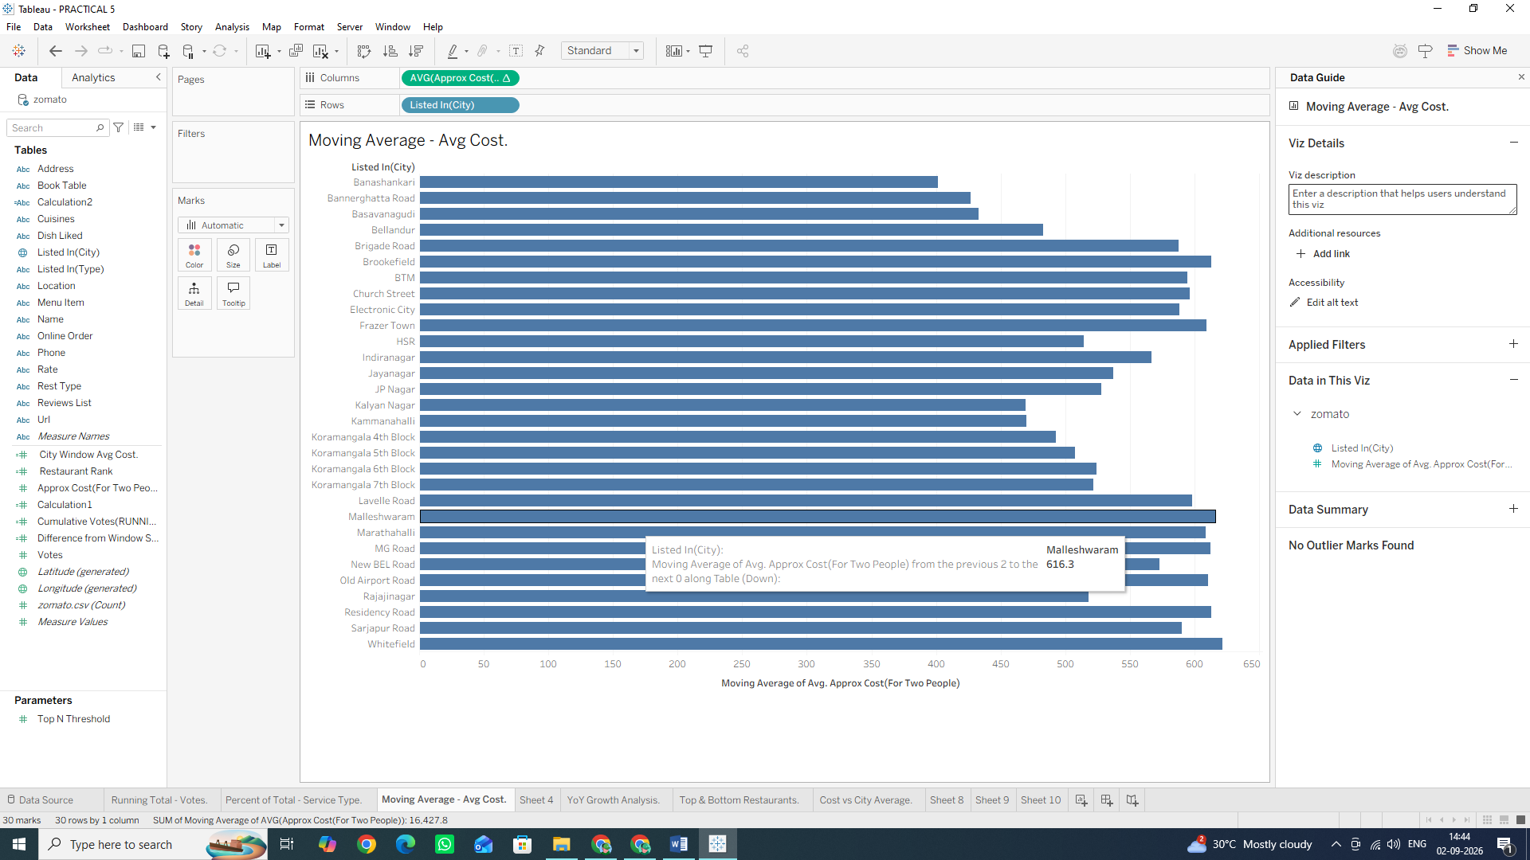
o In the configuration dialog, set Summarize values using: Average
o Set Previous values: 2 and Next values: 0 (This calculates a 3-point moving average including the current city and 2 previous cities).
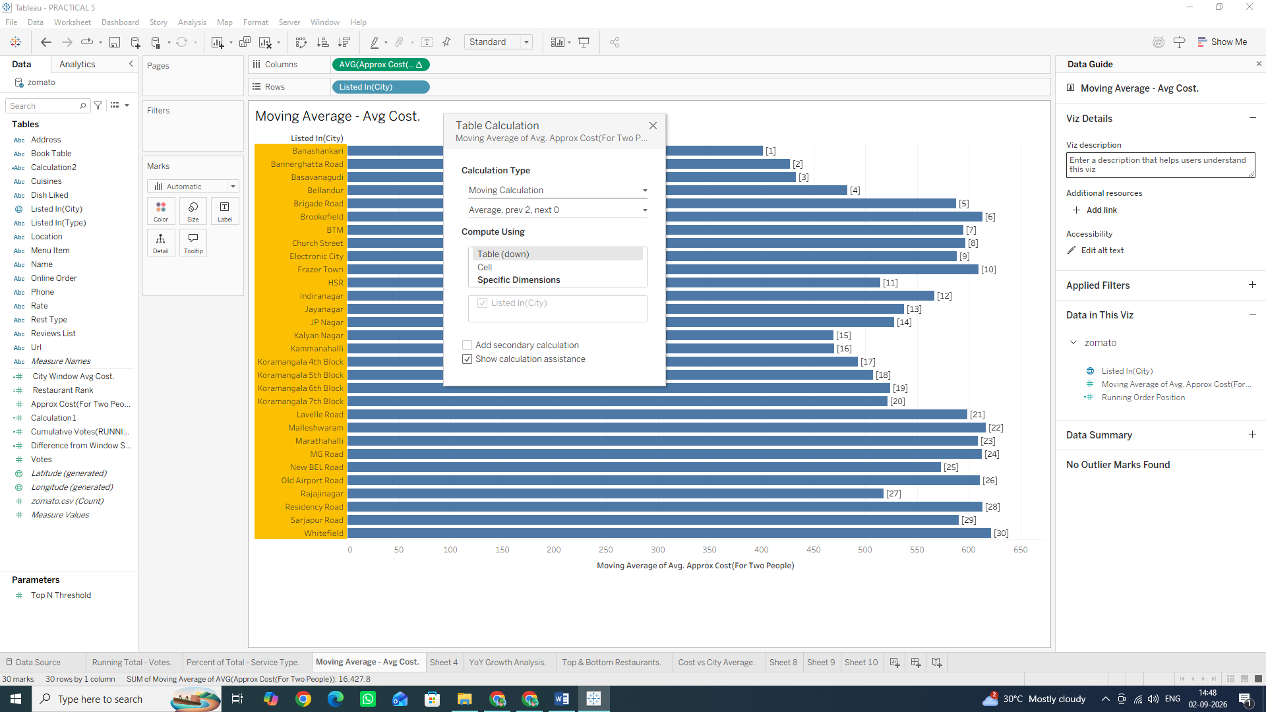
Task 2: Create a Custom Cumulative Metric via Calculated Field
Instead of using Quick Table Calculations, we can write a dedicated Table Calculation function formula directly.
1. Click the small drop-down arrow at the top right of the Data Pane (just next to the Search box) and select Create Calculated Field... Alternative shortcut: Right-click anywhere on a specific field or dimension in the Data Pane ◊ Create ◊ Calculated Field... (or press Alt + Analysis menu ◊ Create Calculated Field).
2. Name the field: Cumulative Votes (RUNNING_SUM).
3. Enter the following Table Calculation formula: RUNNING_SUM(SUM([votes]))
4. Click OK.

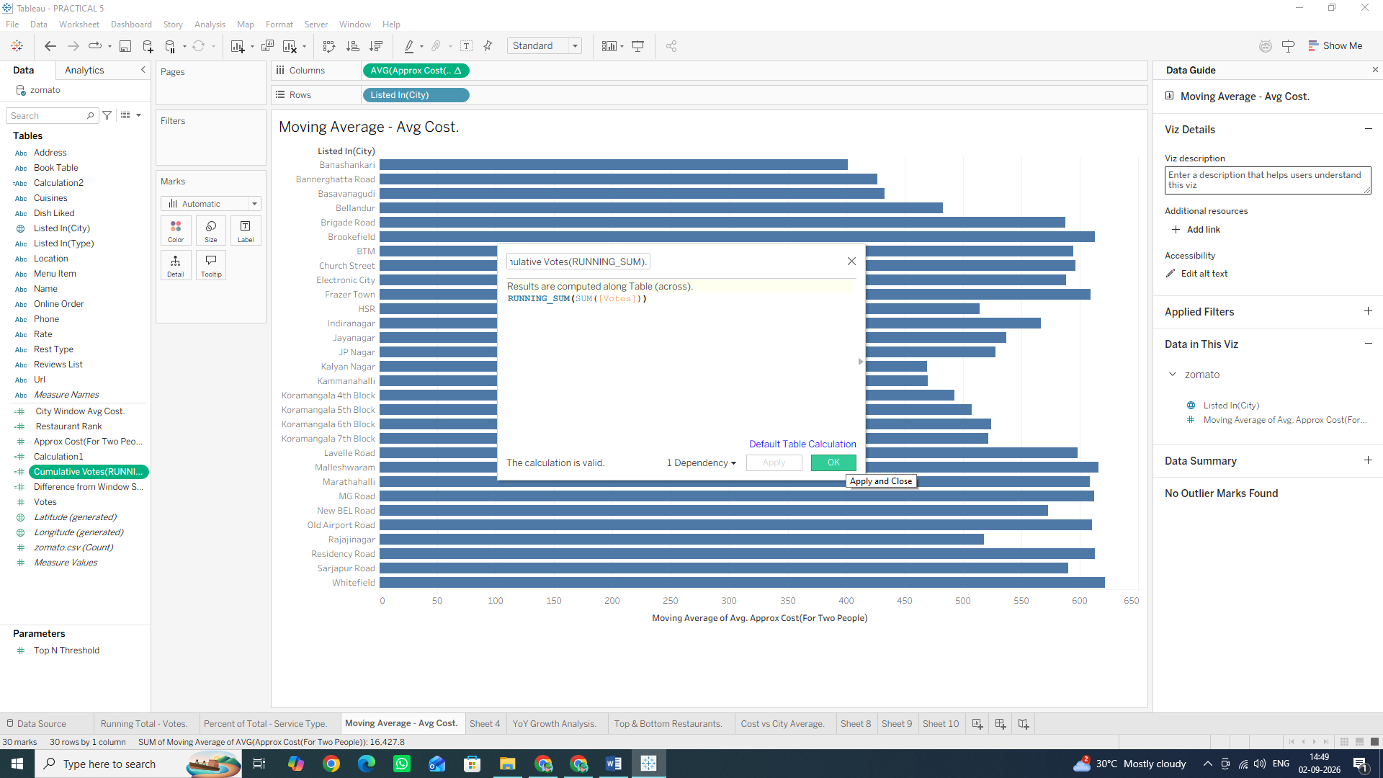
5. Open a new worksheet.
6. Drag cuisines to Rows (Filter to top 15 or 20 if the list is too long).
7. Drag your newly created Cumulative Votes (RUNNING_SUM) field onto Columns.
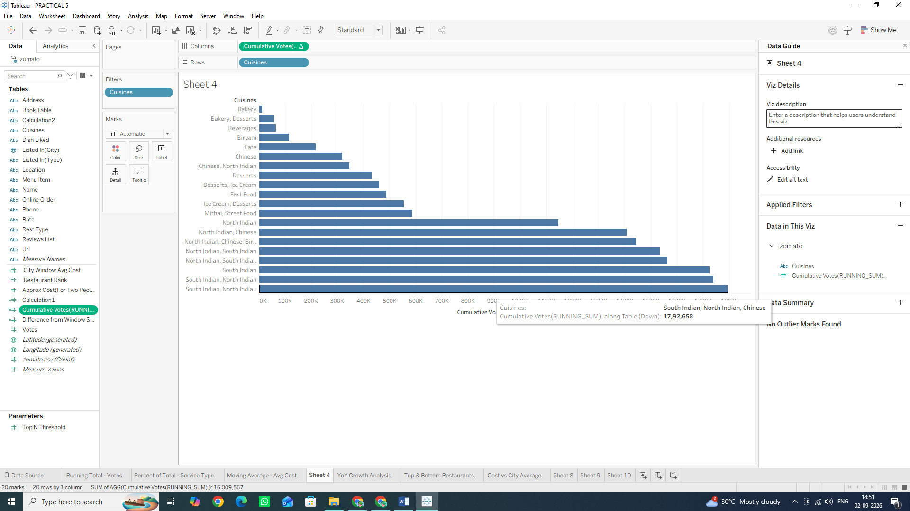

C: Perform year-over-year growth analysis Note:
Since the raw Zomato dataset provides categorical dimensions rather than a built-in transaction date field, we will simulate a Year-over-Year / Period-over-Period growth calculation structure using ordinal categorical periods or numeric ranges, or apply Tableau's native YoY Table Calculation logic.
Task: Calculate Year-over-Year (YoY) / Period-over-Period Percent Growth
1. Open a new worksheet and rename it: YoY Growth Analysis.
2. Place your time dimension (or ordinal grouped column like listed_in(city)) on the Columns shelf.
3. Drag votes (or approx_cost (for two people)) onto the Rows shelf as SUM (votes).
4. Apply the Year-over-Year Growth Quick Table Calculation:
o Right-click the SUM(votes) pill on the Rows shelf.
o Hover over Quick Table Calculation ◊ select Percent Difference (or Year Over Year Growth if using a true Date field).
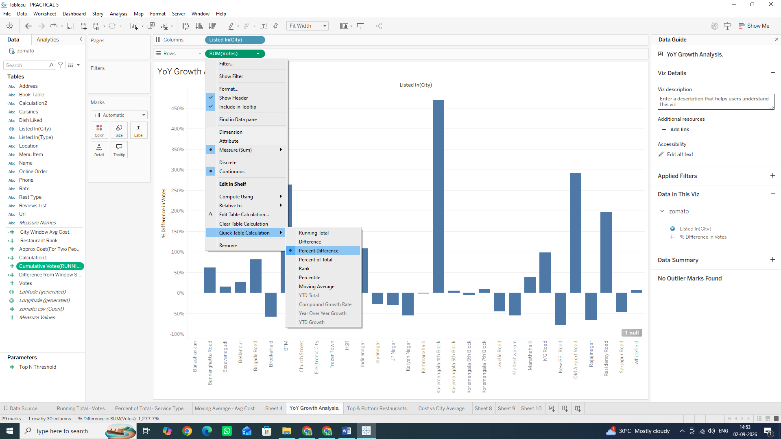

5. Configure the Growth Calculation Direction:
o Right-click the modified SUM(votes) pill (with the Δ icon).
o Hover over Compute Using ◊ select Table (across){In some cases it may have by selected by default}.
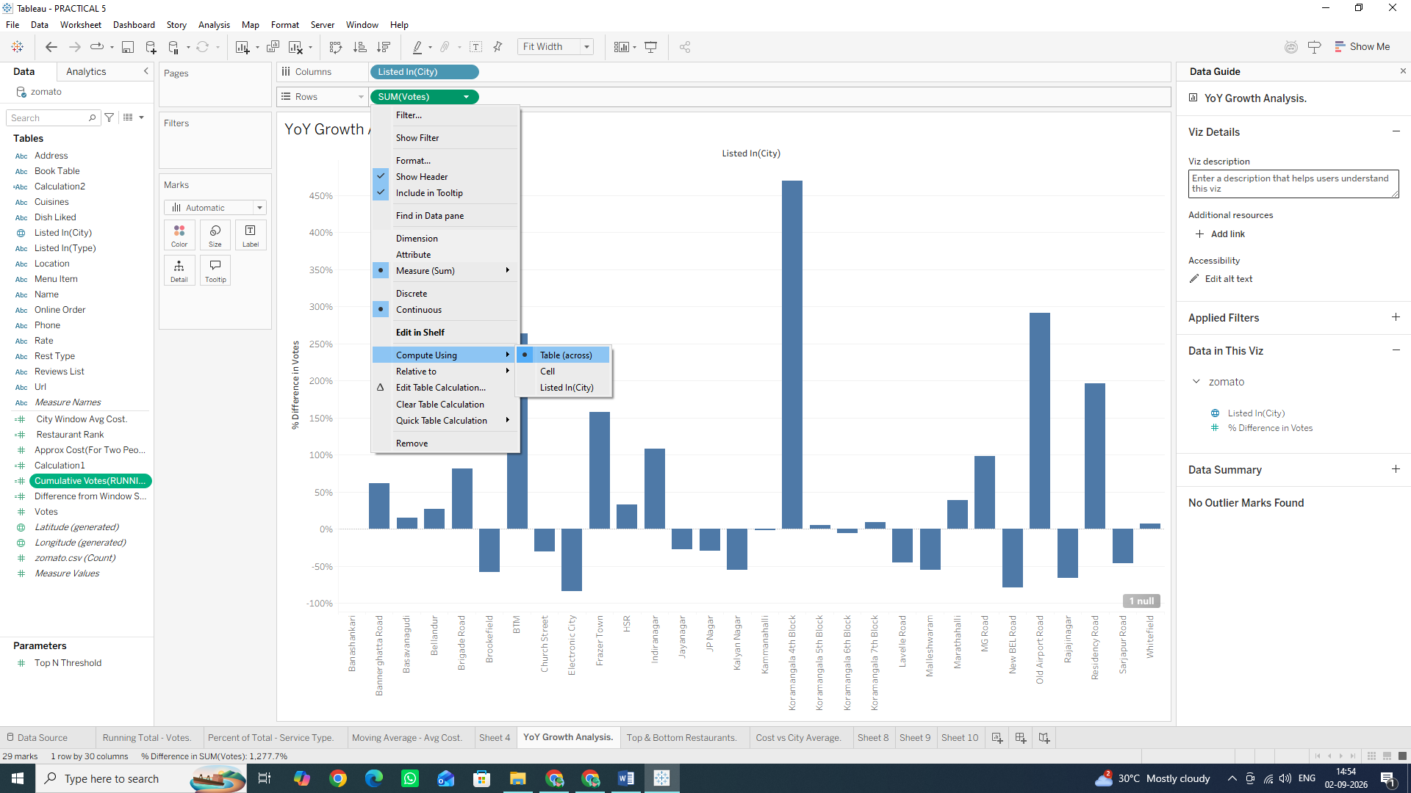
6. Add Visual Colour Indicators:
o Hold down Ctrl (or Cmd on Mac), click and drag the SUM (votes) pill from the Rows shelf, and drop it directly onto the Color mark on the Marks card.
o Positive growth will appear in one color (e.g., Green/Blue) while negative performance dips will turn Red/Orange!
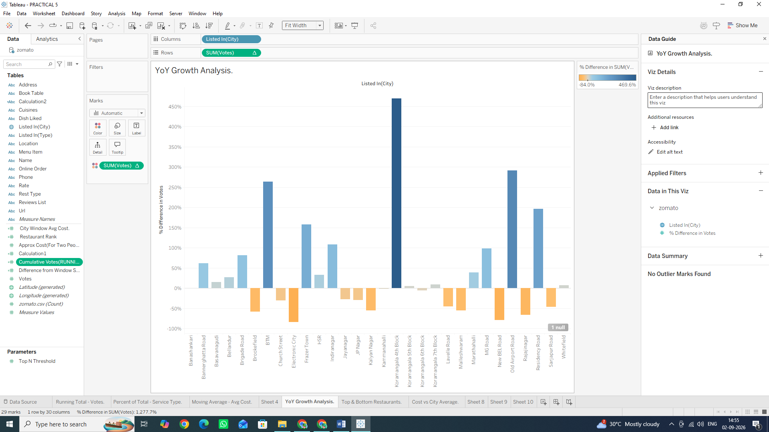
Why We Are Doing It & Usage
• Percent Difference / YoY Growth: Computes the percentage change between the current mark and the previous mark:
• % 𝐺𝑟𝑜𝑤𝑡ℎ = Current Period Value − Previous Period Value Previous Period Value Χ 1 •
Usage: Essential in executive performance dashboards to track financial health, customer acquisition momentum, and seasonal fluctuations.

D: Use ranking functions (Top N, Bottom N)
Ranking table calculations evaluate each row's aggregate value relative to all other rows in the partition, assigning a numeric rank (1, 2, 3...).
Task 1: Create a Rank Calculation 1. Click the small drop-down arrow at the top right of the Data Pane and select Create Calculated Field...
2. Name the field: Restaurant Rank.
3. Input the following ranking calculation:) RANK(SUM([votes]), 'desc')
4. Click OK.

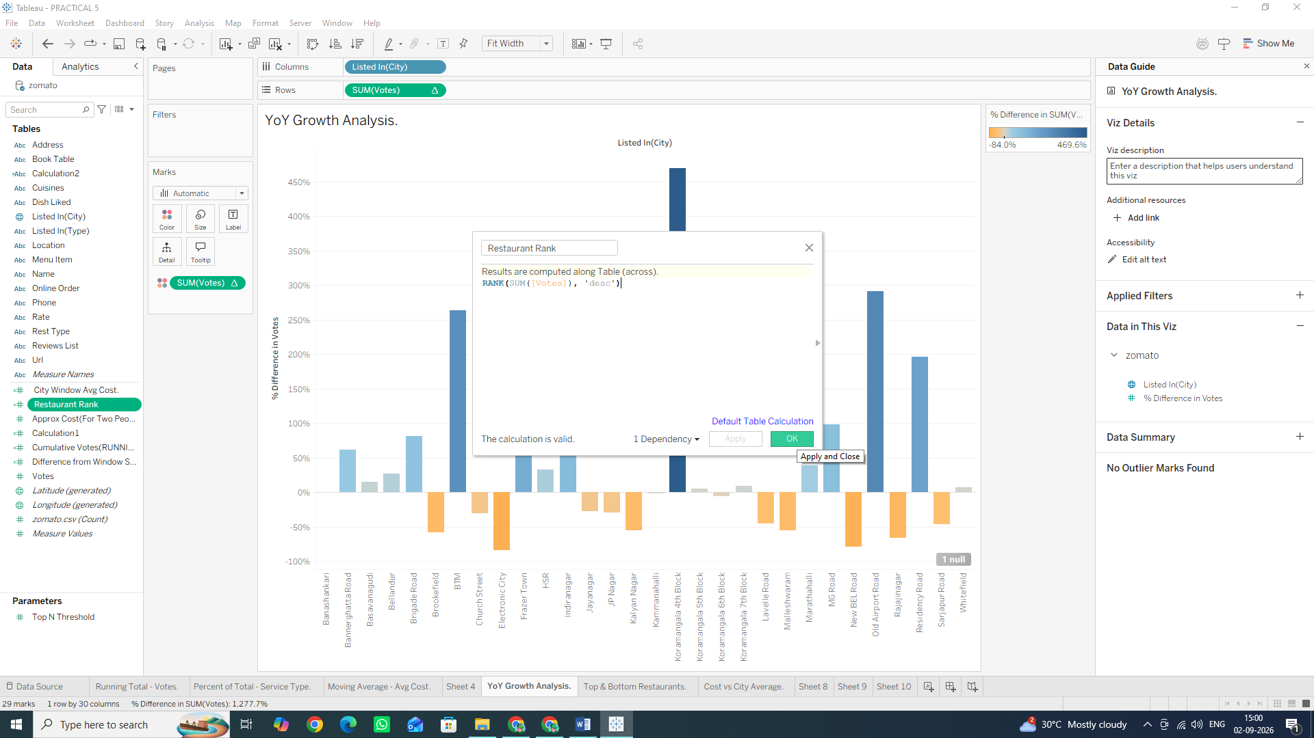
Task 2: Build the Top N / Bottom N Ranked View
1. Open a new worksheet and rename it: Top & Bottom Restaurants.
2. Drag name (Restaurant Name) to the Rows shelf.
3. Drag votes to the Columns shelf.
4. Drag your newly created Restaurant Rank calculated field onto the Rows shelf, placing it to the left of name
5. Convert Restaurant Rank to a Discrete field:
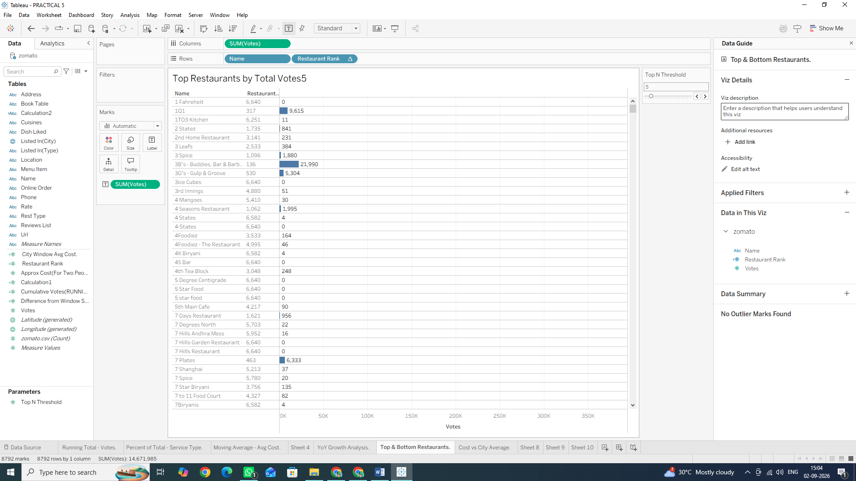
Task 3: Filter Dynamically to Display Top N Only
1. Hold Ctrl (or Cmd on Mac), click and drag the Restaurant Rank pill from the Rows shelf, and drop it onto the Filters card.
2. In the filter dialog box, select a range of ranks (e.g., set the maximum to 15 to show only the Top 15 restaurants).
3. Click OK
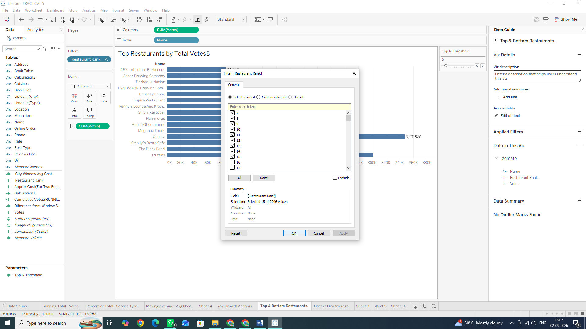
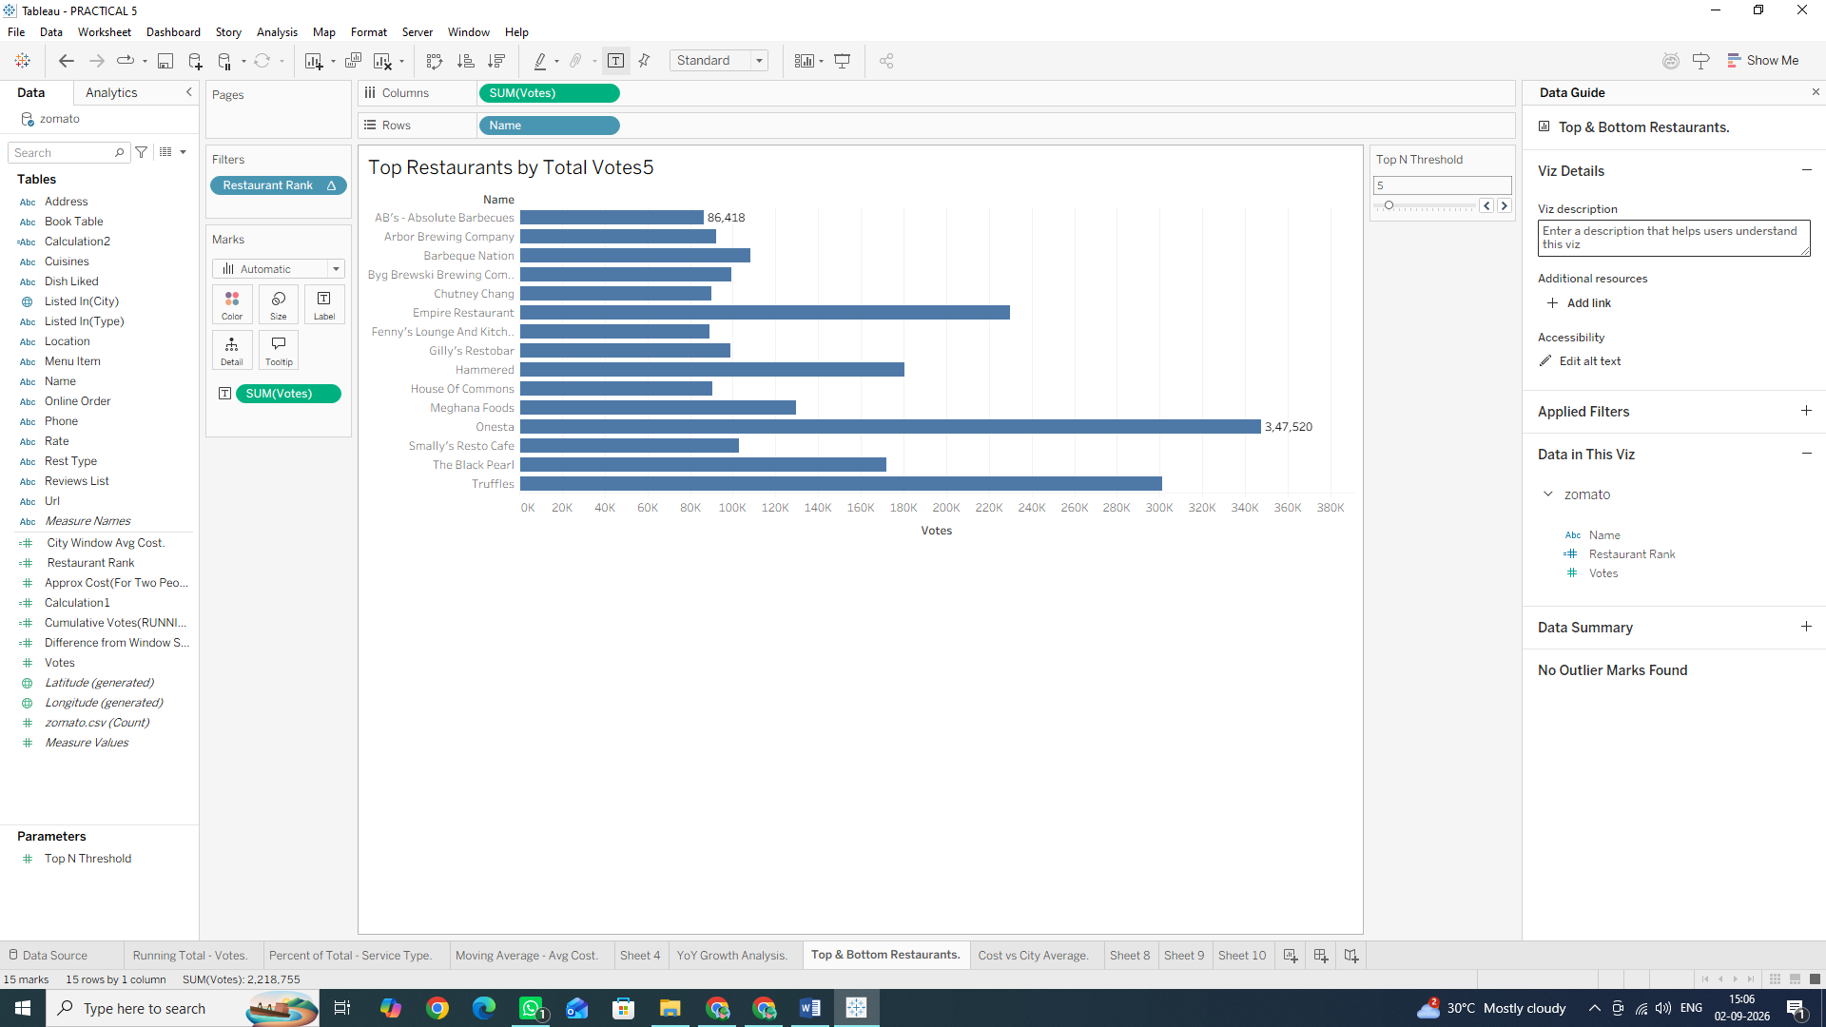
Why We Are Doing It & Usage
• Ranking Functions: Unlike standard sorting, table calculation functions like RANK() and RANK_DENSE() assign explicit numeric positions to dimensions dynamically based on changing filters or metrics.
• Usage: Indispensable for identifying top-performing assets (e.g., Top 10 revenuegenerating locations, lowest-performing product lines, or leaderboards).

E: Implement window functions (WINDOW_SUM, WINDOW_AVG)
Window functions calculate aggregate metrics across a specific window of marks in the view without altering the level of detail on the sheet. Unlike standard aggregations, window functions allow you to compare individual data points directly against a summary metric calculated across the entire window (or a defined subset of it).

Task 1: Create a Window Average Calculation
1. Click the small drop-down arrow at the top right of the Data Pane (next to the Search bar) and select Create Calculated Field...
2. Name the field: City Window Avg Cost.
3. Input the following window function formula: WINDOW_AVG(AVG([approx_cost(for two people)]))
4. Click OK.
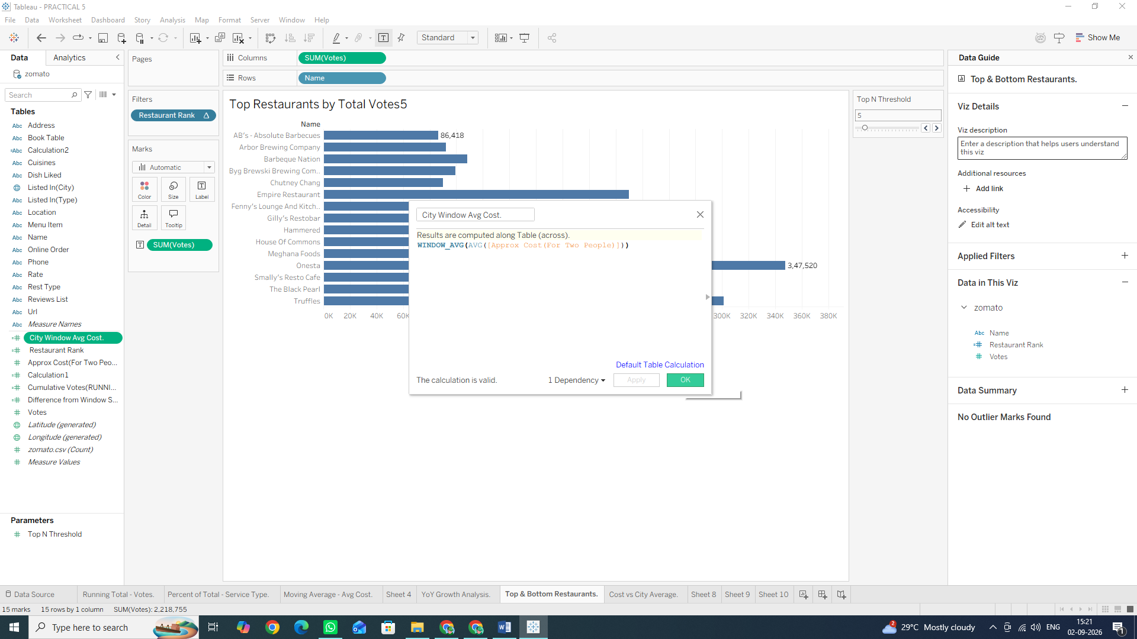

Task 2: Build the Window Comparison Visualization
1. Open a new worksheet and rename it: Cost vs City Average.
2. Drag listed_in(city) to the Rows shelf.
3. Drag approx_cost(for two people) to the Columns shelf. Change its aggregation to Average (Right-click pill $\rightarrow$ Measure (Sum) $\rightarrow$ Average).
4. Drag your newly created City Window Avg Cost calculated field onto the Columns shelf (placing it right beside AVG(approx_cost...)).
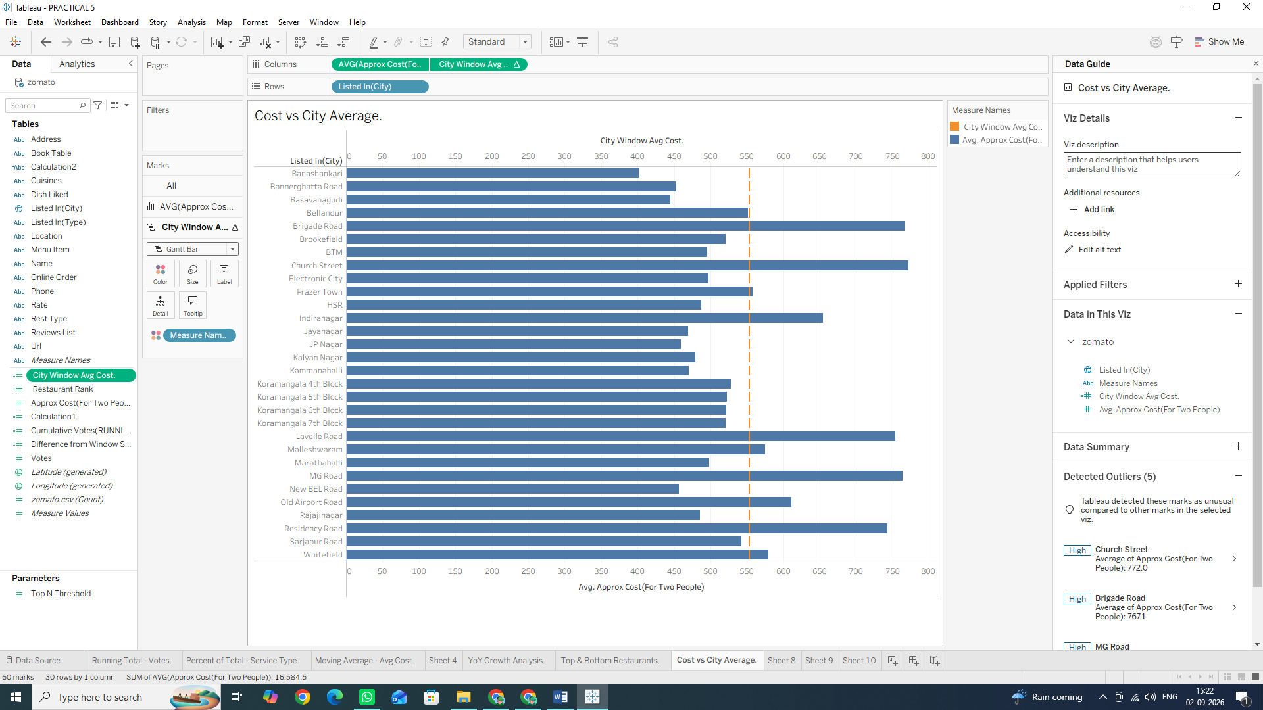
Task 3: Combine Measures into a Dual-Axis Reference View
1. Right-click the City Window Avg Cost pill on the Columns shelf and select Dual Axis.
2. Right-click the top horizontal axis in the visualization view and select Synchronize Axis.
3. In the Marks card:
- Change the mark type for AVG(approx_cost...) to Bar.
- Change the mark type for City Window Avg Cost to Line (or Gantt Bar).
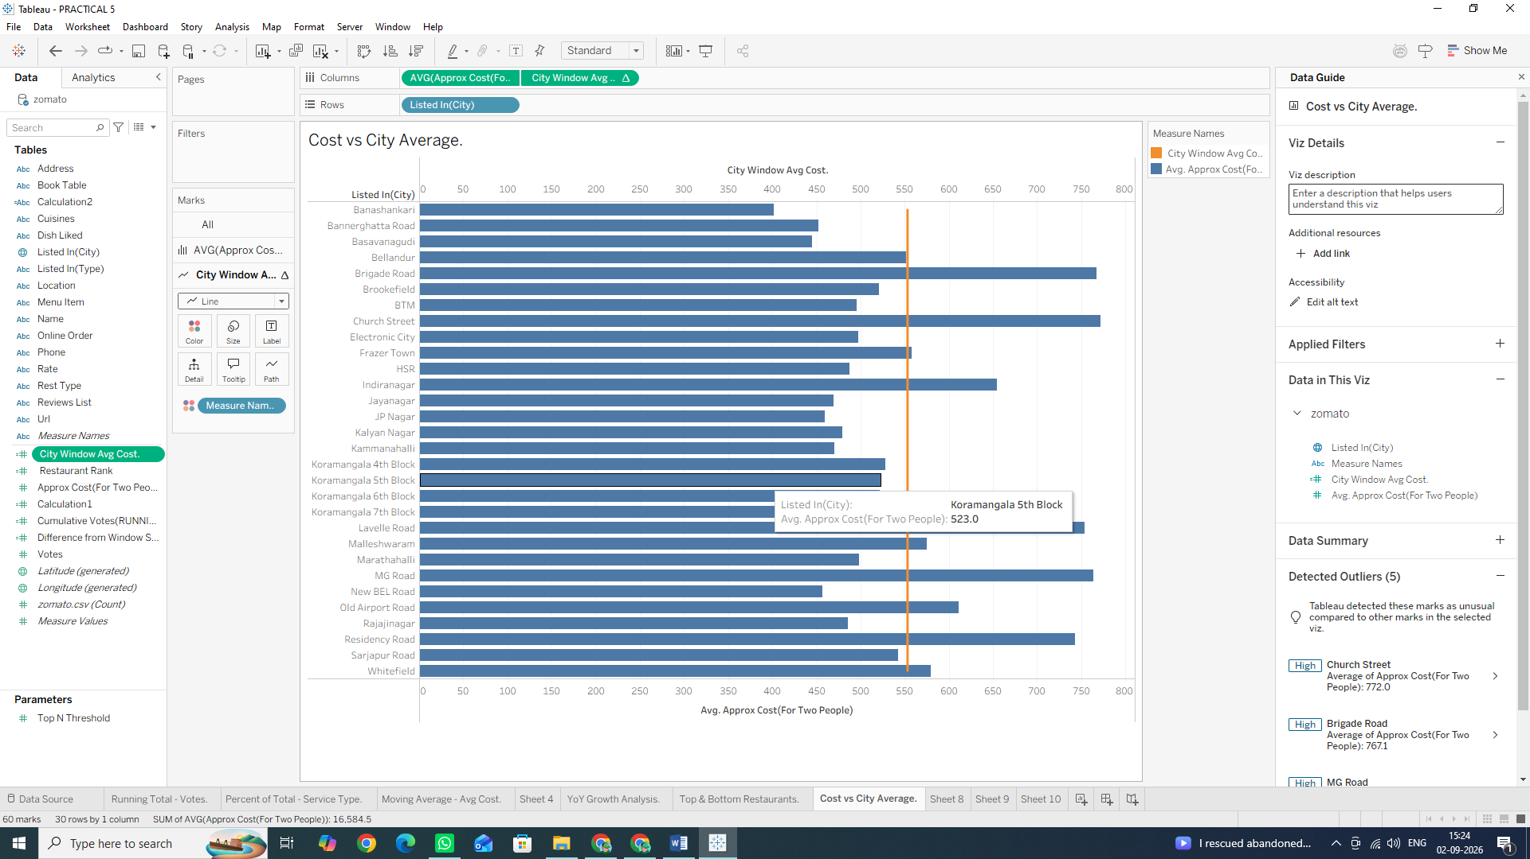
Task 4: Create a Window Difference Metric (WINDOW_SUM)
1. Click the small drop-down arrow at the top right of the Data Pane and select Create Calculated Field...
2. Name the field: Difference from Window Sum.
3. Input the following expression to compare each city's vote count against the total sum of all votes in the visible window: SUM([votes]) - WINDOW_AVG(SUM([votes]))
4. Click OK
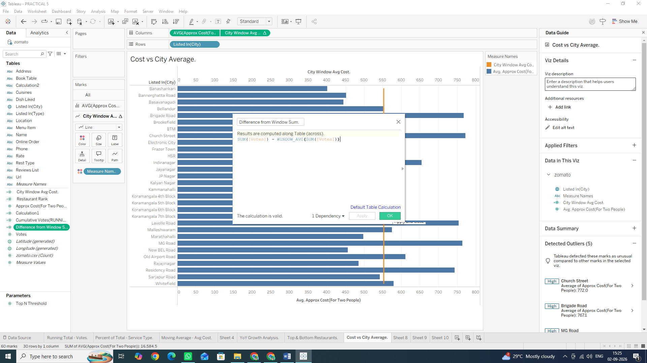
5. Apply it to the View:
- Open new Sheet
- Drag listed_in(city) to the Rows shelf and votes to the Columns shelf.
- Drag your new Difference from Window Sum calculated field onto the Color mark on the Marks card.
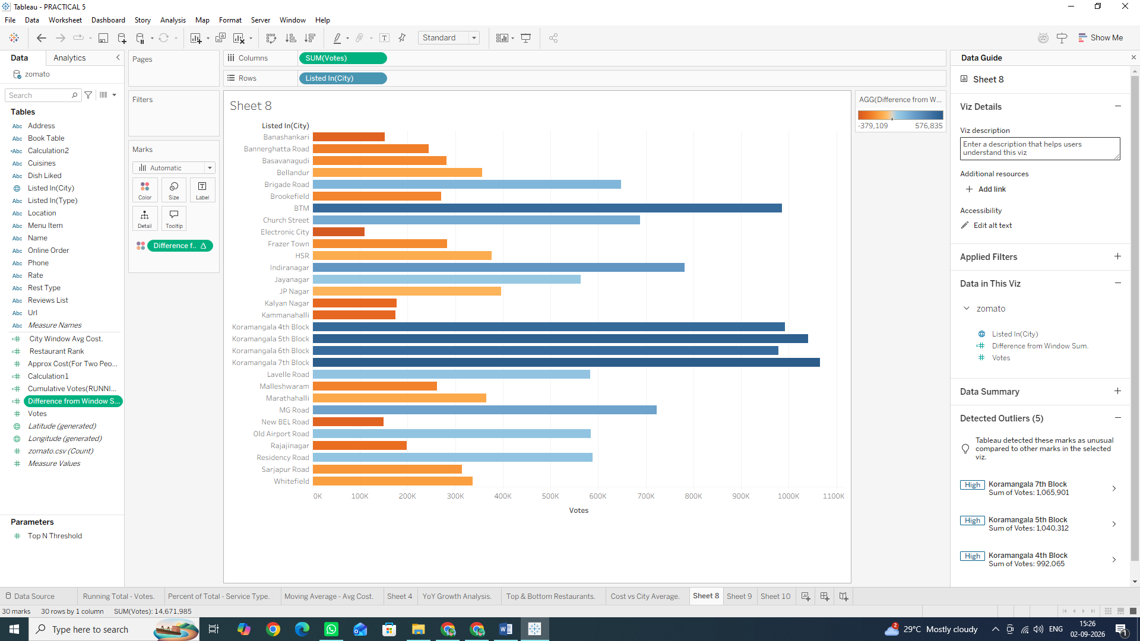
• Result: Bars will be shaded along a color gradient based on how significantly each city contributes to or differs from the total window aggregate.
We Are Doing It
• Window Functions (WINDOW_SUM, WINDOW_AVG, WINDOW_MAX): Allow you to perform computations across all displayed data points on the screen without using a fixed LOD expression or restructuring the underlying query.
• Usage: Essential for constructing dynamic benchmark lines, bullet charts, deviations from overall means, and baseline comparisons across visible dimensions.

F: Customize addressing and partitioning
In Tableau table calculations, Partitioning and Addressing determine how and in what direction a calculation is computed across your view:
• Partitioning Fields (The Groupings): These define how the data is scoped or grouped. The calculation restarts for each partition (e.g., recalculating from 1 for every city).
• Addressing Fields (The Direction): These define the dimensions along which the calculation moves (e.g., ranking restaurants from top to bottom within that city).
Task 1: Build a Nested View for City and Service Type
1. Open a new worksheet and rename it: Addressing vs Partitioning.
2. Drag listed_in(city) to the Rows shelf.
3. Drag listed_in(type) to the Rows shelf, placing it right next to listed_in(city) (creating a two-level nested hierarchy).
4. Drag votes to the Columns shelf as SUM (votes).
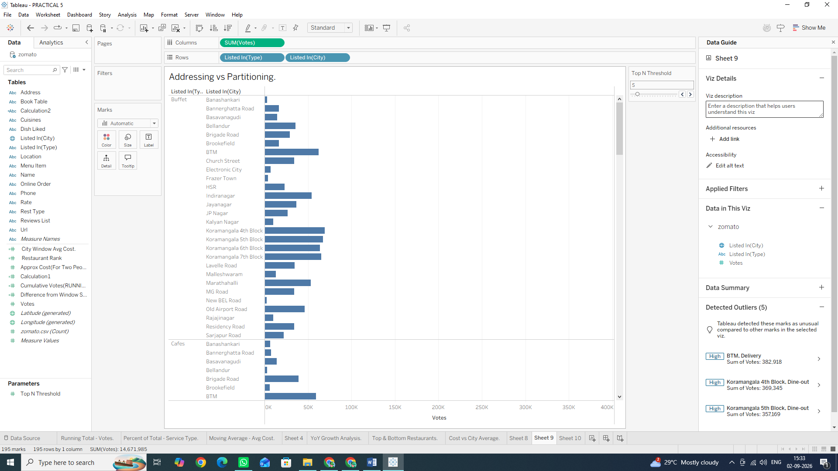

Task 2: Apply Partitioning via "Compute Using" Options
1. Right-click the SUM (votes) pill on the Columns shelf, hover over Quick Table Calculation, and select Rank.
2. Right-click the SUM(votes) pill again and hover over Compute Using:
Select Table (down): Tableau addresses the entire table from top to bottom. It ranks every single row relative to the whole sheet (Partition = Entire Table).
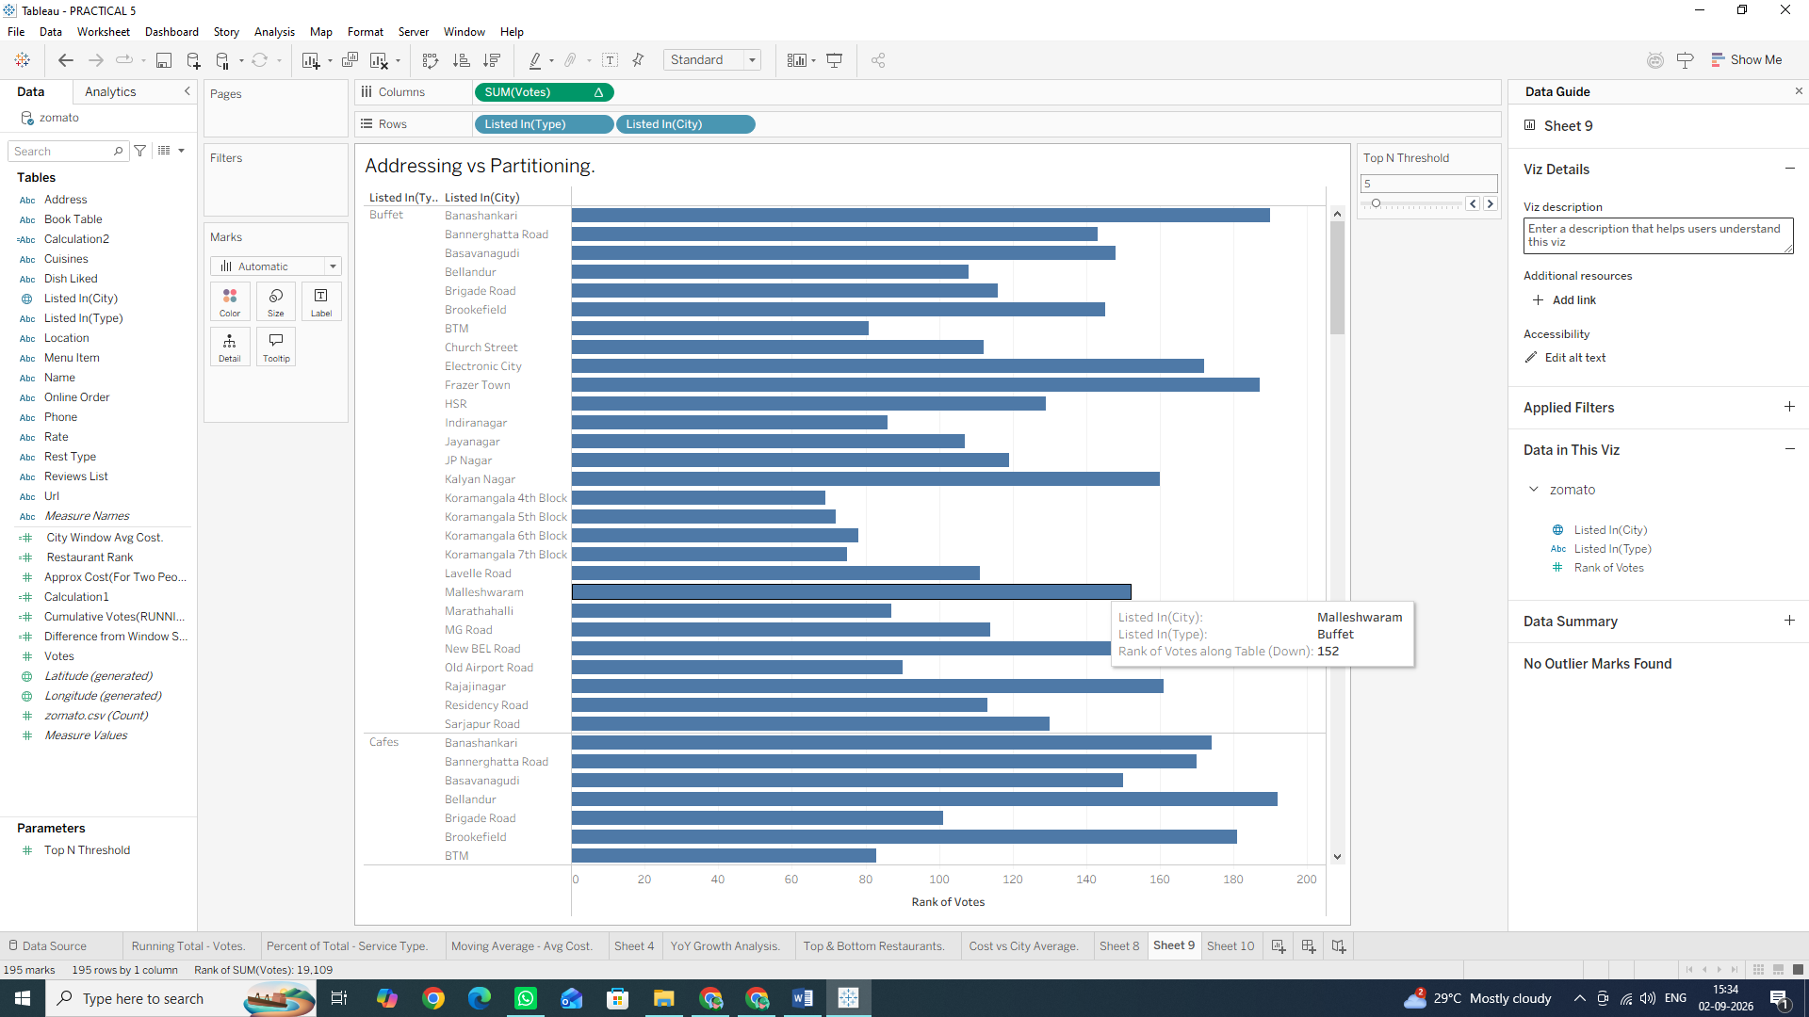
Task 3: Manually Define Addressing with Specific Dimensions
For precise control over complex visual structures, use the Specific Dimensions settings:
1. Right-click the SUM(votes) pill (with the Δ icon) on the Columns shelf and select Edit Table Calculation...
2. Under Compute Using, select the radio button for Specific Dimensions.
3. Observe the checked vs. unchecked boxes:
Checked boxes = Addressing fields: Tableau computes along these dimensions.
Unchecked boxes = Partitioning fields: Tableau restarts the calculation whenever this dimension changes.
4. Uncheck listed_in(city) and leave listed_in(type) checked.

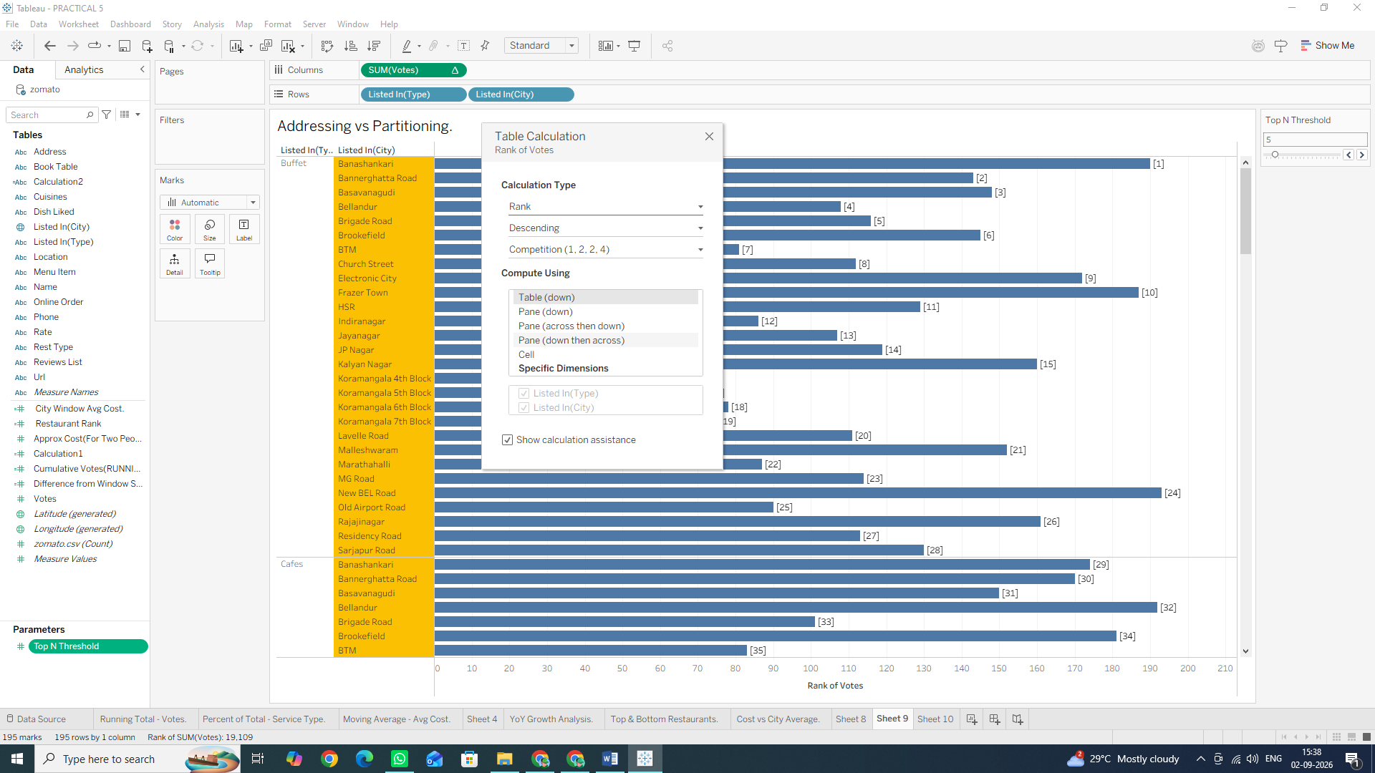

Task 1: Create a Dynamic Label Parameter
1. Right-click anywhere in the Data Pane and select Create Parameter... or click on small triangle drop down button next to search on data pane and select Create Parameter
2. Name the parameter: Top N Threshold.
3. Set Data type to Integer.
4. Set Current value to 5.
5. Under Allowable values, select Range:
- Minimum: 3
- Maximum: 20
- Step size: 1
6. Click OK.
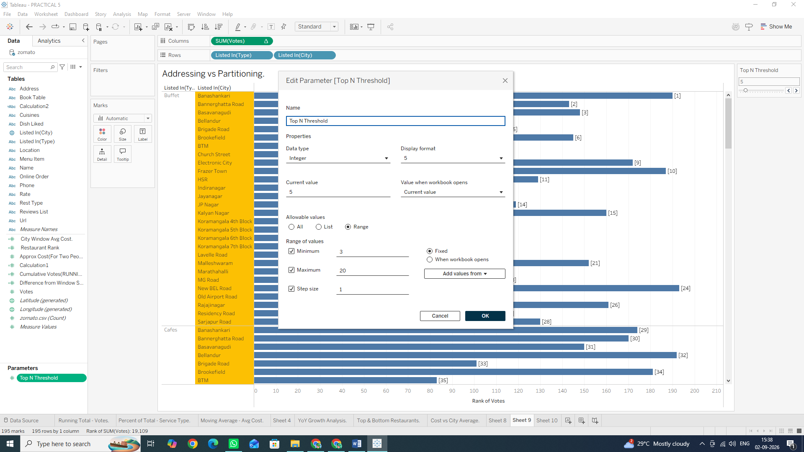
7. Right-click Top N Threshold in the Data Pane and select Show Parameter Control.
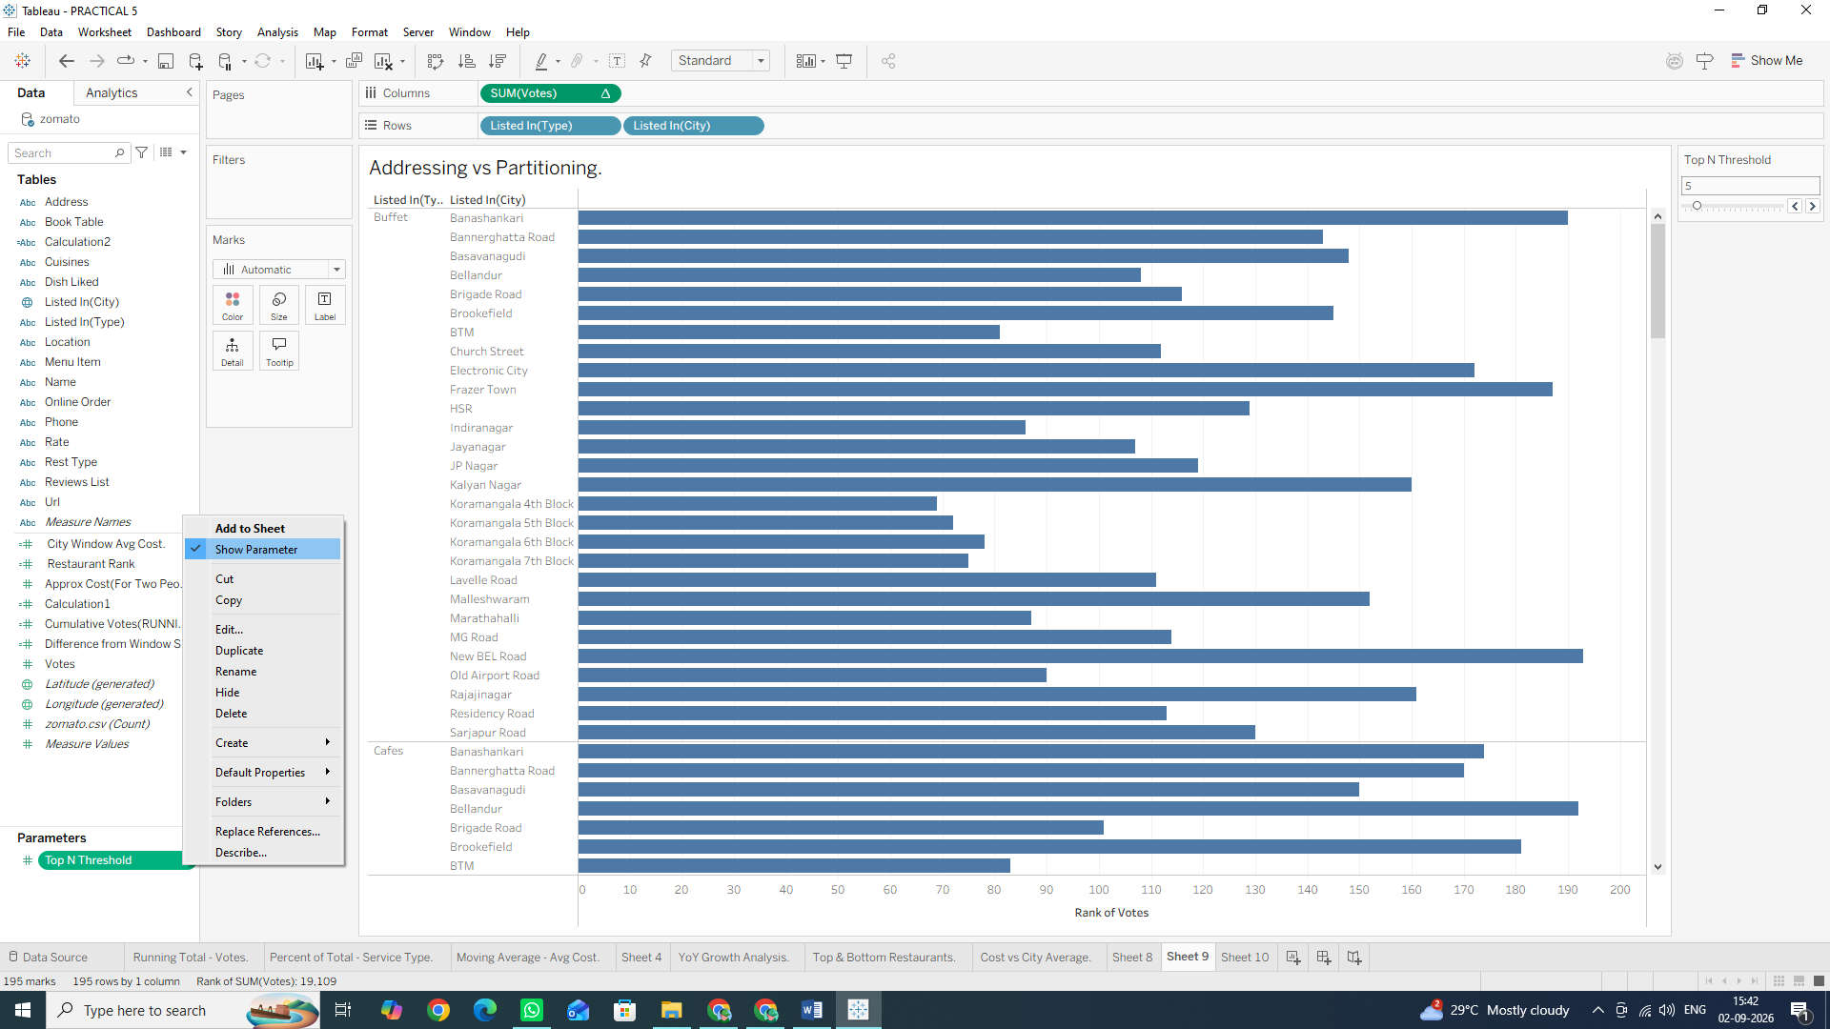

Task 2: Create a Dynamic Header Calculation
1. Create a new Calculated Field named Dynamic Title: "Top " + STR([Top N Threshold]) + " Restaurants by Total Votes"
2. Click OK.
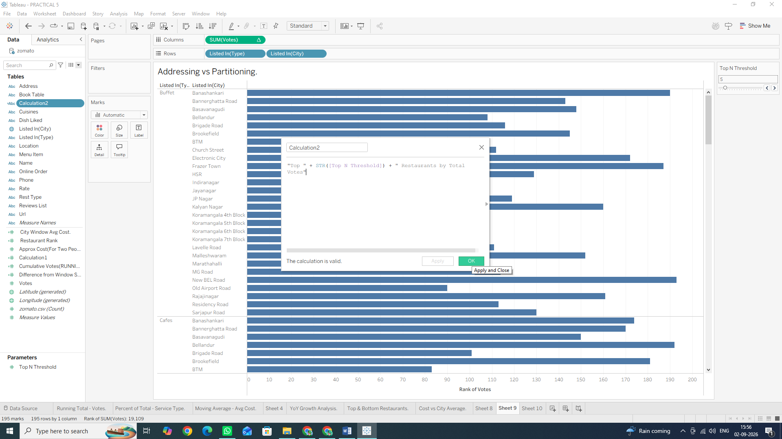
Task 3: Embed Calculated Fields and Parameters into the Sheet Title
1. Double-click the Sheet Title at the top of your worksheet (e.g., Top & Bottom Restaurants).
2. Clear the existing text.
3. In the Edit Title dialog box, click the Insert button in the top right corner.
4. Select Parameters.Top N Threshold from the list.
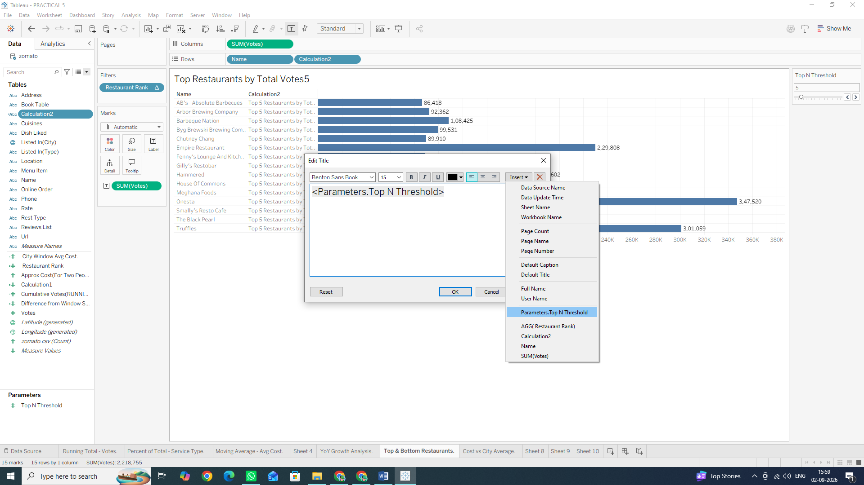
5. Format the title text so it reads: Top Restaurants by Total Votes
6. Click OK.
7. Adjust the Top N Threshold parameter slider on your sheet to test how the title updates dynamically!
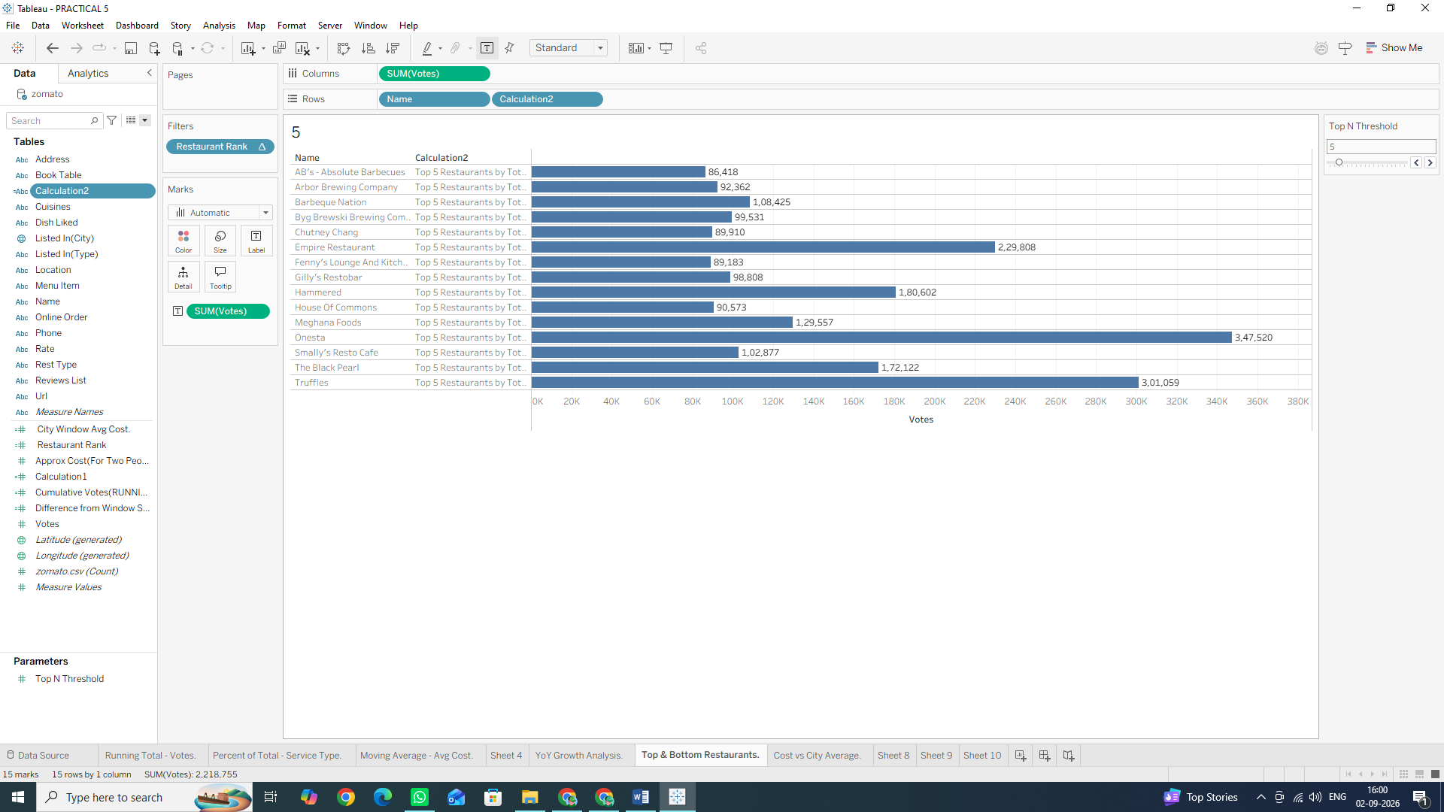

Task 4: Add Dynamic Mark Labels (Highlighting Extremes)
1. Drag SUM(votes) to the Label card on the Marks card.
2. Click the Label card to open options:
- Under Marks to Label, select Min/Max.
- Under Field, select SUM(votes).
- Under Options, check Allow labels to overlap other marks (if needed).
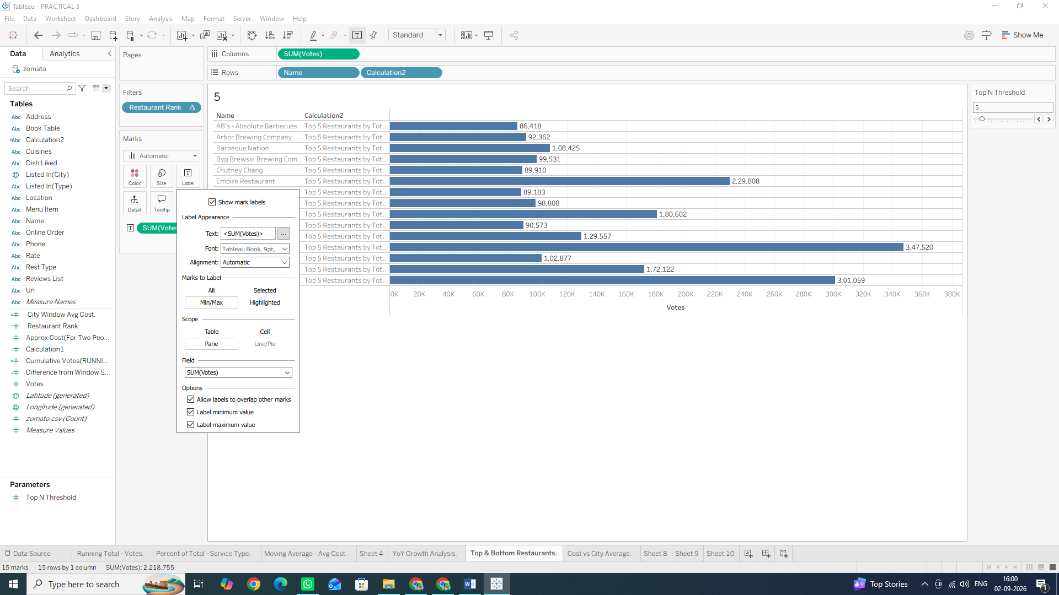
Why We Are Doing It
• Dynamic Titles & Mark Formatting: Hardcoded titles become misleading when users interact with parameters and filters. Embedding parameter values and table calculations directly into headers creates self-documenting charts.
• Usage: Critical for executive dashboards, interactive analytical reports, and automated slide decks where context changes based on user input.

